**Project Description for Vipassanā ‐ Insight Awareness (VIA)**

**Taha Mohamed Alzein, 269055;**

**Oskars Arajs, 266534;**

**Dragos Chirtoaca, 253742;**

**Pascari Liviu, 266094;**

**Joseph Chukwudi Okika (JOOK)**

**Mikkel Cortnum Poulsen (MCOP)**

**Mona Wendel Andersen (MWA)**

**ICT Engineering**

**I Semester**

**10 October 2017**

**Table of content**

1 Background description 1

2 Definition of purpose 2

3 Problem Statement 3

4 Delimitation 4

5 Choice of models and methods 5

6 Time schedule 6

7 Risk assessment 7

8 Sources of Information 8

Appendices (including Group Contract)

# Background description

VIA is a center for spiritual events originally with a base in the Buddhist principles of meditation as an insight with awareness of what happens when it happens. Today events at VIA also include spiritual practices not directly related to any religion like dream interpretations, healing, astrology, reincarnation, karma, alternative health care and similar events.

VIA helps organize these events and journeys for people with interest in different categories starting from exploring one’s mind and learning how to deal with inner conflicts.

Up until now, they used pen and paper to keep track of their lectures, lecturers and upcoming events. But that system is only viable if the number of lectures and events are low. Otherwise, the system gets overwhelmed and it gets hard to keep track of all of the data and needed resources to keep the organization going.

Due to previous experience, VIA’s board members have acknowledged the fact that their system can’t handle all of the lectures that take place in the premises and at the same time keep track of all of the events and journeys that are a part of the “Awareness” program. This problem occurs due to the fact that the system they use is outdated. If the system is kept VIA not only could but also would definitely lose time and resources by trying to keep a dying system maintainable.

For this reason VIA’ board members have decided that there is a need for a project like this, due to the fact that since it has started growing in terms of audience and like-minded peoples participation in VIA’s events.

In other words, the need for a stable system in which employees and users can upload or search for relative information is a growing demand due to the fact that technologies are advancing and have become a part of every company in modern times.

# Definition of purpose

The purpose is to create a system that can handle data related FE.

# Problem Statement

The project main problem is that currently the company has a lack of possibilities of sorting and searching for finalized events in a time period for the newsletter. It is hard to find non-finalized events to finalize them and search for sponsors for the newsletters. On the other hand, the searching for lecturers in a given category in order to create new events it’s almost impossible and finding events or lecturers specifying a category for potential new events and store members including their email addresses. Moreover, checking if the members payed their membership is made manually.

Questions to be answered are:

1. How to implement the system in JAVA?
2. How to make the system maintainable?
3. How to connect the system to a database?
4. How to integrate the calendar with the website?

# Delimitation

* The calendar with the events will not be synchronized with the calendar from the smartphone;
* The customers will not be able to give feedback unless we ask for it through email;

# Choice of models and methods

Table 1, Choice of models and methods

|  |  |  |  |
| --- | --- | --- | --- |
| **What - partial problem.** | **Why - study this problem.** | **Which methods/ models/ theories will be used?** | **Who - in the group is the main responsible person for this point?** |
| **make events’ system** | To make the events easily manageable in term of sorting and searching and adding as well. | Analyse the requirements and modelling the event part based on that requirements.  Design database | Oskars, Liviu, Dragos, and Taha. |
| **managing members** | To make the members easily manageable and searchable | Analyse and design a member’s module based on requirements. | Oskars, Liviu, Dragos, and Taha. |
| **Managing lecturers** | To make managing lecturers and finding lecturers for a given category for potential new events easier | Analyse and design a lecturer’s module based on requirements. | Oskars, Liviu, Dragos, and Taha. |
| **Managing sponsors** | To manage sponsors and make finding a sponsor for potential new events easier | Analyse and design a sponsor’s module based on requirements. | Oskars, Liviu, Dragos, and Taha. |
|  |  |  |  |

Source: Elaborated by authors

# Time schedule

The time scope is estimated to 550 group-working hours. Monitoring the workload is a paramount need for managing the project from the first phase until the final hand in. For this, Trello tool will be used. Website Development is estimated to be finished until 28.09.2017. The second deadline is Project Description that needs to be finished until 26.09.2017 where the third phase will start which is System Construction. The last and the most important phase Testing part will be started on 21.12.2017 when the Construction phase is estimated to be finished.

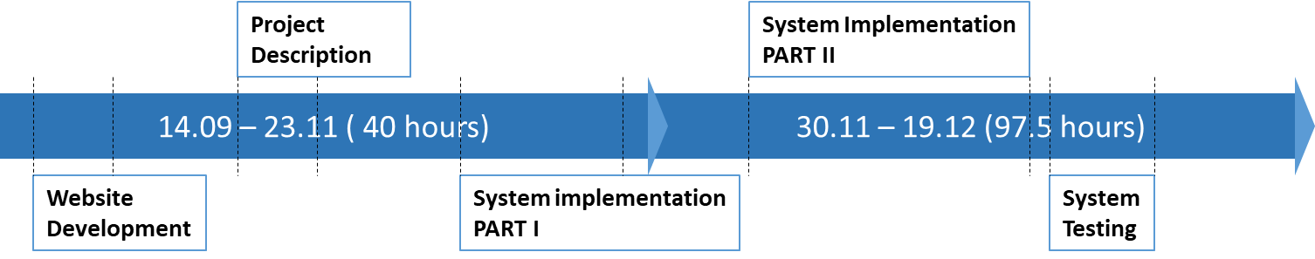

Figure 1, Project timeline

Source: Elaborated by authors

# Risk assessment

Table 2, Risk assessment model

|  |  |  |  |  |  |  |
| --- | --- | --- | --- | --- | --- | --- |
| Risks | Description | Likelihood scale: 1-5  5=high risk | Severity scale: 1-5, 5 = high impact | Risk mitigation e.g. Preventive - & Responsive actions | Identifiers | Responsible |
| Lack of planning | Not sufficient planning and work overload | 2 | 4 | Using apps like Trello that will repartees the tasks between members | Being late with the handing of the task. | Taha |
| Obstacles in the group | Lack of motivation, discipline, communication, involvement | 3 | 3 | Creating of a pleasant environment in the group, more discussion and more meetings. | Lack of presence of one or more members in the work activity | Liviu |
| Loosing files | Losing the unsaved files as a result of computer failure. | 4 | 5 | Back up of files using desktop app called GitHub. | Loss of unsaved work. | Oskars |
| Meeting the deadline | As a result of not monitoring the work that was already done and the work that should be done | 3 | 4 | Using apps like Trello that will monitor the work load of all members, as soon we finish as better it is. | Being late with the project hand-in | Dragos |

Source: Elaborated by authors

# Sources of Information

For content see Appendix 1 “VIA Engineering – Project Description Guidelines”.

**Appendices**

For content see Appendix 1 “VIA Engineering – Project Description Guidelines”.